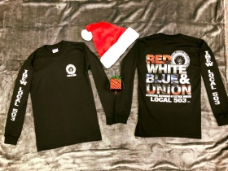
Long Sleeve Red, White and Blue Union Shirt- $25 each
(Please indicate the quantity of each size)

Small _____ Medium _____ Large _____ X-Large _____ XXL_____ XXXXL____
Total $________
Name___________________________________________________

Work location________________________________

Department__________________________________

Phone_______________________________________
Please check one:

Pick up at Hall

Send Inter-office mail

*Please send order form and check or money order made out to IBEW Local 503 to the Union Hall inter-office mail ATTN: Melissa Durant.

